Nested Tables:

<!DOCTYPE html>

<html lang="en">

<head>

    <meta charset="UTF-8">

    <meta name="viewport" content="width=device-width, initial-scale=1.0">

    <title>Nested Tables</title>

    <style>

        .main {

*border-color*: blueviolet;

*border-style*: solid;

*border-width*: 4pt;

*text-align*: center;

        }

        .main td {

*border-style*: solid;

*border-color*: blueviolet;

*border-width*:1pt;

        }

        .nested td {

*border-style*: solid;

*border-color*: red;

*border-width*: 1pt;

        }

        .nested {

*border-color*: red;

*border-style*: solid;

*border-width*: 4pt;

        }

    </style>

</head>

<body>

    <table class="main" cellpadding="2em">

        <tr>

            <td rowspan="2">Left side of the main table</td>

            <td>

                <b>Nested Table</b>

                <table class="nested">

                    <tr>

                        <td>nested table C1</td>

                        <td>nested table C2</td>

                    </tr>

                    <tr>

                        <td>nested table </td>

                        <td>nested table</td>

                    </tr>

                </table>

            </td>

        </tr>

    </table>

</body>

</html>

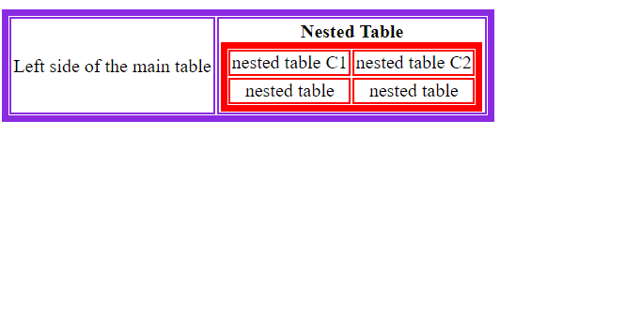

Image Map:

<!DOCTYPE html>

<html lang="en">

<head>

    <meta charset="UTF-8">

    <meta name="viewport" content="width=device-width, initial-scale=1.0">

    <title>Blue Rectangle Image Map</title>

    <style>

        body{

*text-align*: center;

        }

    </style>

</head>

<body>

    <img src="Class Map Nested/rectangle.jpg" usemap="#rectangleblue" alt="A blue rectangle" >

    <map name="rectangleblue">

            <area shape="rect" coords="199,99,400,400" alt="Story1" href="Class Map Nested/Story1.html">

            <area shape="rect" coords="402,99,600,400" alt="Story2" href="Class Map Nested/Story2.html">

            <area shape="rect" coords="600,99,800,400" alt="Story3" href="Class Map Nested/Story3.html">

    </map>

</body>

</html>

